Right click on the project Run As → Spring Boot App
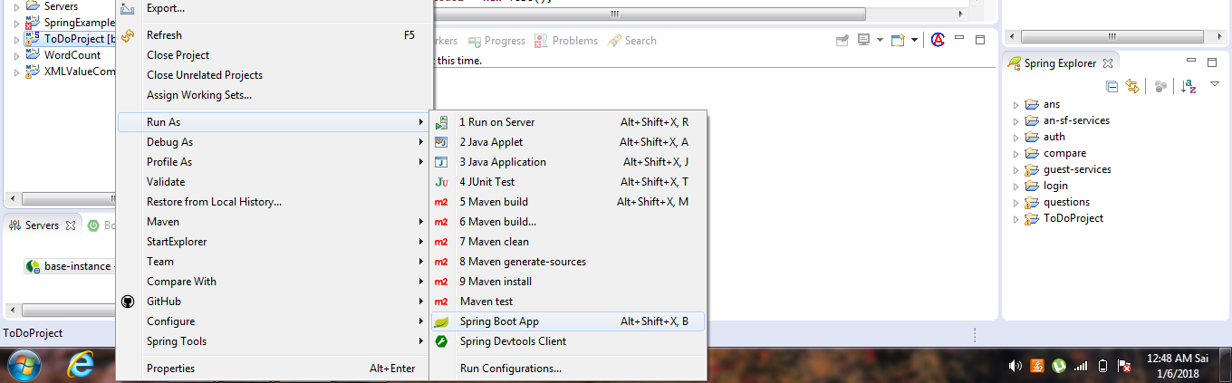

Please check if tomcat is started without erros
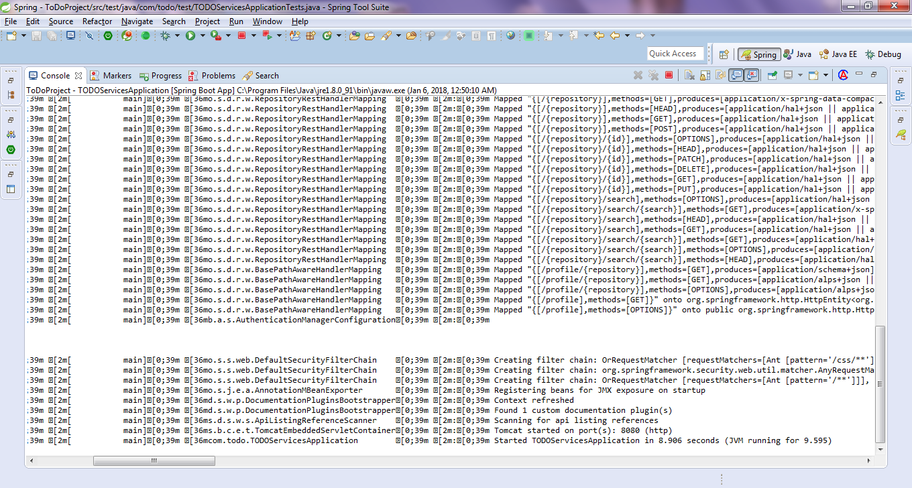

Type the below url → Opens the swagger Configuration.
http://localhost:8080/swagger-ui.html
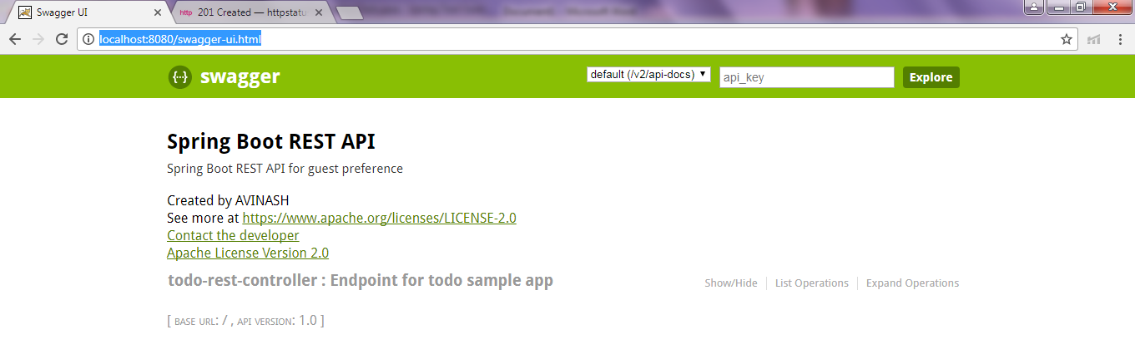

Add new Todo Item (add 1 or 2 items by pasting valid jsons)
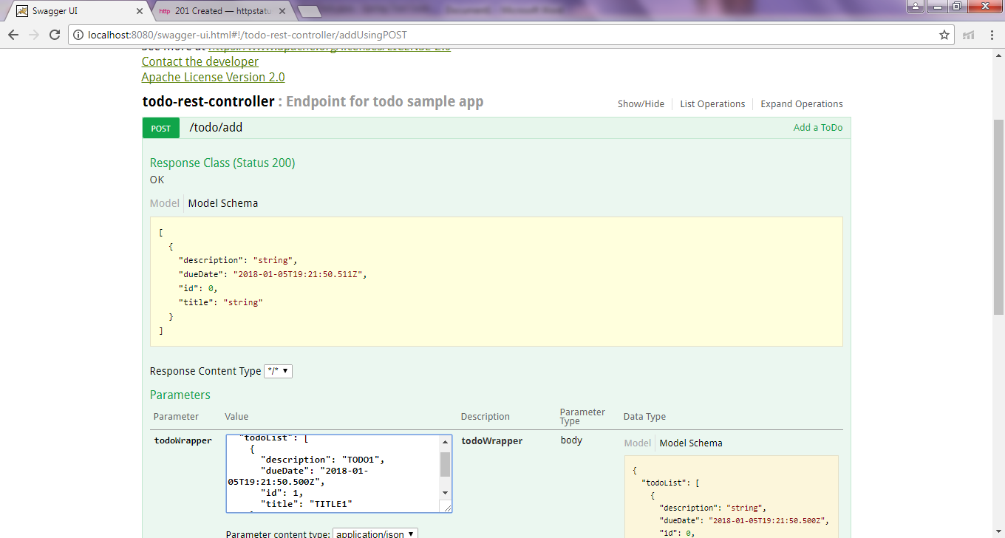

For update todo Update 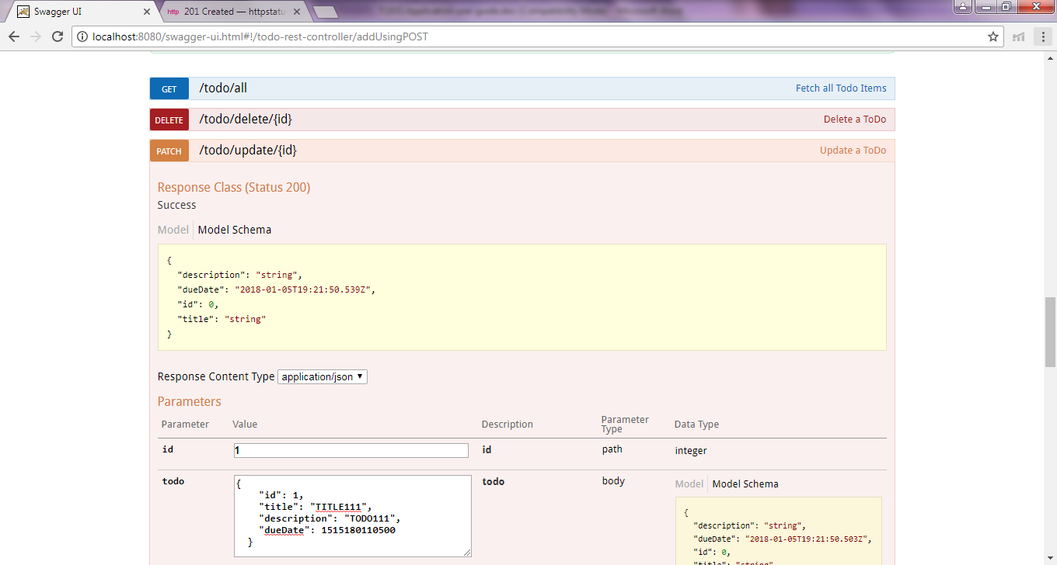
Update result in postman
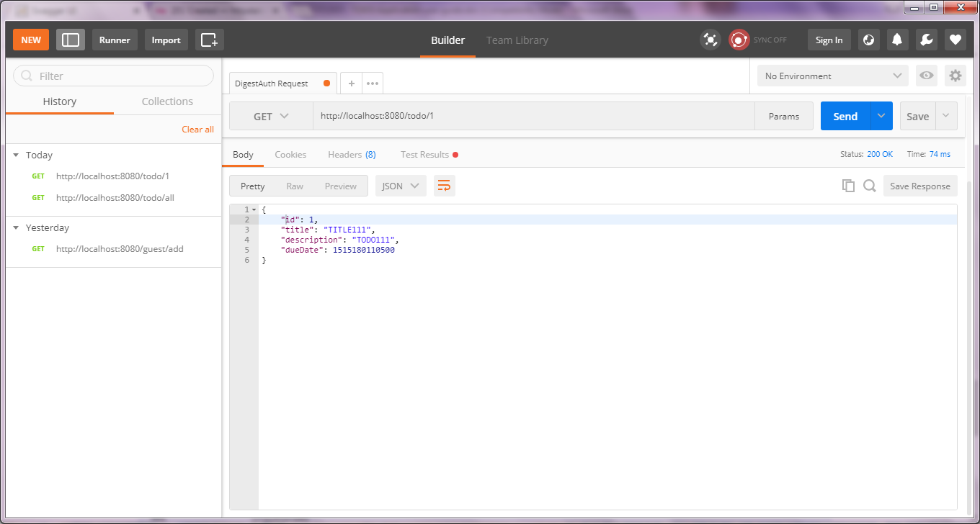

Go to postman give the following url to retrieve all the toDo Items
http://localhost:8080/todo/all

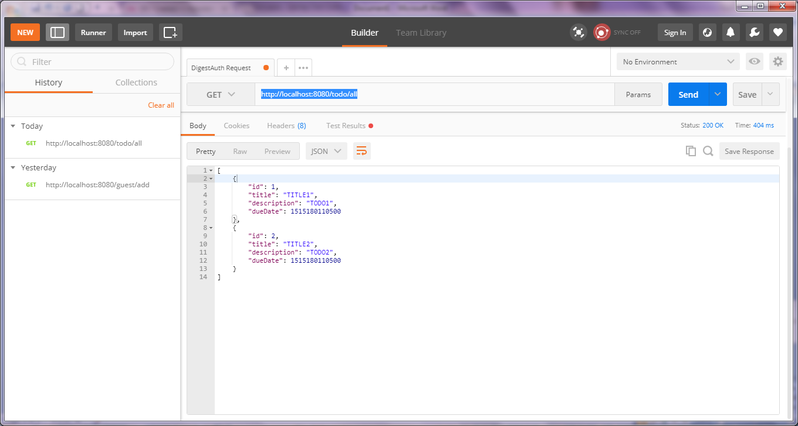
This will display the added items

Give the following in post man
http://localhost:8080/todo/1 to retrieve Item based on Id {1}

